

**PROGRAMMING 2**

**STIA1123**

**INDIVIDUAL ASSIGNMENT :**

**EXERCISE 1 (OBJECT-ORIENTED EXAMPLES)**

**NADZIRAH BINTI MOKHTAR (282051)**

**LECTURER NAME :**

**PROF MADYA DR. AZMAN B. YASIN**

**SEMESTER 2 2021**

**Exercise 1**

**Object-oriented examples**

|  |
| --- |
| **myRuler** |
| brand = “Shinwa ruler”  color = “Grey”  madeFrom = “Steel” |

EXAMPLE 1

**Class : Ruler**

|  |
| --- |
| **Ruler** |
| -brand : String  -color : String  -madeFrom : String |
| +drawStraight() : void |

|  |
| --- |
| **ainRuler** |
| brand = “Astar ruler”  color = “White”  madeFrom = “Plastic” |





EXAMPLE 2

|  |
| --- |
| **perfume1** |
| brand = “Chanel”  scent = “Aromatic and Floral”  madeIn = “Paris”  priceRinggit = “RM 350” |

**Class : Perfume**

|  |
| --- |
| **Perfume** |
| -brand : String  -scent : String  -madeIn : String  -priceRinggit : int |
| +changePrice(newPrice : int) : int |

|  |
| --- |
| **perfume2** |
| brand = “Marc Jacobs”  scent = “Soft and Soft Oriental”  madeIn = “American”  priceRinggit = “RM 250” |

|  |
| --- |
| **perfume3** |
| brand = “DIOR”  scent = “Mossy Wood and Fruit”  madeIn = “Paris”  priceRinggit = “RM 400” |

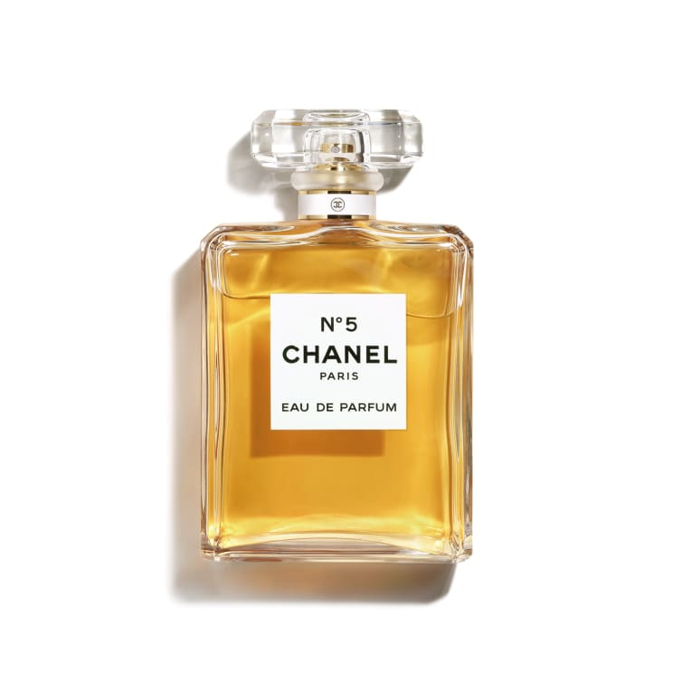

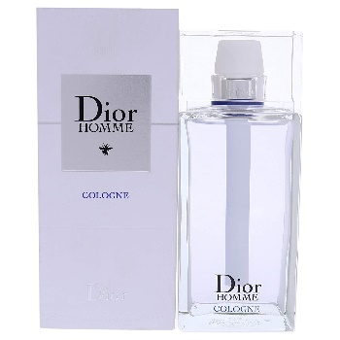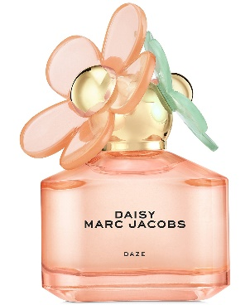

EXAMPLE 3

**Class : Student**

|  |
| --- |
| **student1** |
| name = “Aina”  university = “UKM”  grade = “3.70” |

|  |
| --- |
| **Student** |
| -name : String  -university : String  -grade : double |
| +getName() : void  +getUniversity() : void  +getGrade() : double |

|  |
| --- |
| **student2** |
| name = “Hawa”  university = “UMS”  grade = “2.5” |

|  |
| --- |
| **student3** |
| name = “Ahmad”  university = “UUM”  grade = “4.0” |





EXAMPLE 4

**Class : Author**

|  |
| --- |
| **authorSarah** |
| name = “Ain Maisarah”  email = “www.ainmaisarah@gmail.com”  gender = “female” |

|  |
| --- |
| **Author** |
| -name : String  -email : String  -gender : char |
| +Author(name : String, email : String, gender : char)  +getName() : String  +getEmail() : String  +setEmail(email : String) : void  +setGender() : char |

|  |
| --- |
| **authorMiziWahid** |
| name = “Mizi Wahid”  email = “www.miziwahid@yahoo.com”  gender = “male” |



EXAMPLE 5

**Class : Animal**

|  |
| --- |
| **cat** |
| name = “Princess”  eat = “Royal Canin” |

|  |
| --- |
| **Animal** |
| -name : String  -eat : String |
| +Animal(name : String)  +getName() : String  +setName(name : String)  +eat() |

|  |
| --- |
| **fish** |
| name = “Delta”  eat = “Palaquin” |

